Critical Essay 2: Rhetorical Analysis
of a Visual Argument
Due Dates: 7 Mar 2011 – Rough Draft, bring 2 copies 100 points
10 mar 2011 – Final Draft, submit in folder
Length: 1200 words (approx. 4 pages) + works cited page
Sources: One of the advocacy ads attached to this assignment sheet.
Either Boaz or Marshall’s essay
Assignment: In this essay, you are to use Chapters 8 and 9 from Writing Arguments to write a four-page rhetorical analysis of an implicit claim made by one or two important visual elements in one of the advocacy ads that follow this assignment sheet. (See page 3 in WA for our text’s explanation of implicit arguments.) Additionally, use either Marshall’s “Drug Prohibition is Effective” or Boaz’s “Drug Prohibition is Counterproductive” (remember them?) as a counter-argument or alternative view to your position: what would they say about the ad that you’ve chosen to analyze?

What to do: There are surprisingly few places where we can go and not be confronted by advertisements of some kind, and for this reason it is especially important that we develop a critical understanding of how they work.

- Spend some time studying the ad and making notes on all of the design features you notice. What kind of color scheme does it use? What sort of font? What kind of attitude does the font project? Does the image have a definite focal point? If so, what design features draw the viewer’s eye to it? What design features are the most important to the argument?

- Once you’ve developed a list of the design features, spend some time working out explicit and implicit the claims that they make. What is the explicit argument of the ad? What is its goal? What does it want you to do? Then, ask what sorts of implicit claims it makes in order to support that explicit claim. (For example, think back to the Marlboro ad that we discussed in class: the explicit claim was, of course, “Buy Marlboro,” and to make the brand appealing, it made implicit claims about masculinity, about blue collar men, about male sexuality, and so on.)

- From the list of implicit claims, then, pick the one or two you feel to be most effective, interesting, or problematic. Which of the design features make this claim possible? Use these two elements – the implicit claim and the major visual design choices – to form your thesis.
For example…
Working with the Marlboro ad, we might come up with a thesis that looks like this: “The lines formed by the man’s chaps, shirt, and jacket create a sense of masculine sexuality by drawing the viewer’s eyes to the model’s groin, and this design feature thus makes the Marlboro brand seem powerful, alluring, and attractive. While it may make the ad effective, it is also an emotionally manipulative rhetorical move since cigarettes and sexuality have little to do with each other.”

- Once you’ve written a working thesis that you’re comfortable with, spend a few moments planning out the body paragraphs in a rough outline before starting to write.

- Using Marshall and Boaz: Where you place Marshall or Boaz is up to you, but I’d like for you to use them as an alternative view or objection to the argument you make about the ad. Thus, if you’re arguing that the NORML ad is an effective argument, use Marshall to present an alternative view by hypothesizing what he would say about the ad, and vice versa for Marshall. Respond by either conceding or refuting.

Essay Structure: Your introductory paragraph should explain the issue and any relevant contextual or background information that your reader needs to know before beginning the essay. As part of the introduction, provide a brief summary of the ad’s explicit argument. As usual, the thesis should come at the end of the introduction, it should make a clear claim about the rhetoric of the advocacy ad’s argument, and it should indicate the major points that you will make in your essay. Make your thesis statement as specific as possible. (There are examples of strong thesis statements on p. 159 and 162 of Writing Arguments.)
Tip: Remember that, as we’ll discuss in class, both of these visual arguments make resemblance claims, so be sure to mention the two sides of the comparison in the intro.
Then present your rhetorical analysis in the following body paragraphs. Stick to the focus you established in your thesis statement. In each body paragraph, be sure to use evidence from the ad to support and illustrate your claims.

Responding to Objections and Alternative Views: Briefly present an alternative view to your argument by imagining what either Boaz of Marshall would say about your argument. Fairly summarize their position, and respond by either refuting or conceding their points. Refer to Chapter 7 in WA for more help with this.

In the conclusion, then, wrap up your argument, but try to do more than just repeat your major claims. Try instead to give your reader something additional to think about by considering the broader implications of your analysis.

Note: Page 159 in Writing Arguments gives you a model for constructing a rhetorical analysis essay, and pages 160-164 have a sample essay that you can use as an example for writing your own. Please be sure to consult these valuable models as you write your analysis.

Criteria for Evaluation:
- Analysis: Essay identifies an effective, interesting, or problematic design choice in the ad and evaluates this choice in light of the article’s intended audience and rhetorical context. Analysis demonstrates a thorough understanding of the ad by pushing past a “surface” reading of this choice and connecting it to its implicit claims.
- Evidence: Essay includes evidence in the form of textual quotes and paraphrases and references to specific design choices, but evidence does not overwhelm the author’s own argument.
- Response to Objections and Alternative Views: Essay fairly and accurately presents an alternative view from either Boaz or Marshall’s essay. The essay effectively responds by refuting or conceding to this view.
- Organization and Structure: Essay is clearly and logically organized. Introduction is short and focused. Analysis makes up the bulk of the essay.
- Style and Readability: Essay follows MLA format and is free from distracting grammatical and mechanical errors.

Course Rational: This assignment is designed to give you practice with rhetorical analysis in another genre, and having the ability to break down complex visual arguments will enable you to be a more savvy consumer of advertising and visual media in general.

Option 1:

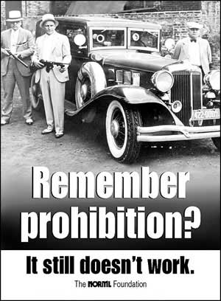

Source: www.norml.org

Option 2:

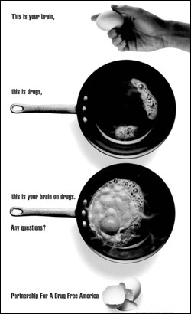

Print version of the infamous anti-drug television commercial.
Source: http://journalism.missouri.edu/alumni/larre-johnson-71.html

