Microtheme 3: Working with Alternative Views
Due: 3 March 2011 25 points
Length: 500 words (approx. 1.5 pages) Sources: One of the advocacy ads in this document
Boaz and Marshall’s essays
Assignment: In this microtheme, you’re going to get a head start on writing part of Critical Essay 2 by using what WA calls dialectical thinking to figure out how either Boaz or Marshall would respond to the advocacy ad that you’ve selected to analyze. (See pages. 45-46 for more on dialectical thinking, especially the list of questions on p. 46).

What to do:
First, pick the image that you’d like to analyze in this microtheme and in CE2. Write a paraphrase of its explicit claim – what does this ad want you to do?

Once you’ve done that, reread both Marshall and Boaz’s essay, making sure to note any places where they make points that could be put in conversation with the ad.

Then, spend one paragraph discussing what Marshall would be likely to say about the ad you’ve chosen. As part of this discussion, be sure to point to specific pieces of evidence from his essay that supports your claims. Then, in the second paragraph, discuss how Boaz would respond to the argument. What would these two authors say about the ad that you picked?
In other words: It’s pretty clear that Marshall would agree with the argument of “This is your brain on drugs.” Thus, your job in this paragraph it to point to specific things Marshall says in “Drug Prohibition is Effective” that show us why he would agree with its argument.
This exercise thus makes you put yourself in both Boaz and Marshall’s shoes for the purpose of determining how they would respond to the ad. In CE2, then, you’ll use either Boaz or Marshall as an alternative view.

Criteria for Evaluation:
- Representation of Opposing Views: Microtheme fairly and accurately represents how Marshall and Boaz would respond to the advocacy ad.
- Evidence: All claims are supported by evidence from the essays and the ads.
- Organization and Structure: Paragraphs are clearly and logically organized.
- Style and Readability: Microtheme follows MLA format and is free from distracting grammatical and mechanical errors.

Course Rational:
Determining how these two writers would respond to this ad is a valuable exercise in thinking through how two different people would view the same argument and will enable you to write a successful CE2.

Option 1:

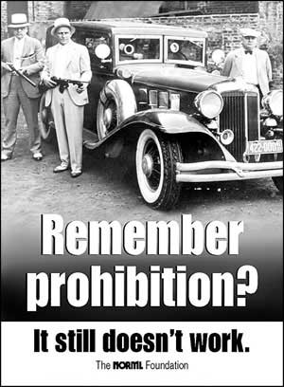

Source: www.norml.org

Option 2:
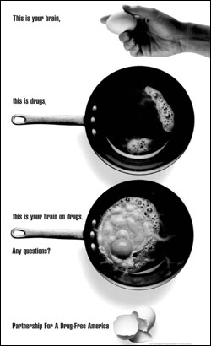

Print version of the infamous anti-drug television commercial.
Source: http://journalism.missouri.edu/alumni/larre-johnson-71.html

